Lesson 9: Rational Functions
Math 2412 Precalculus · Unit 2: Polynomial, Rational, Exponential & Logarithmic Functions · Student Guided Notes
Name: ______________________________ Date: ______________

Lesson objective
Students will find the domain, holes, intercepts, and vertical, horizontal, and slant asymptotes of rational functions, and will use a sign test to sketch their graphs.

Before class
Complete these short tasks before the lesson. They review skills this lesson builds on.
- Factor $x^{2}−2x−3$ and $x^{2}+4x$ (Lesson 1).
- Simplify $\frac{x^{2}−1}{x^{2}−2x−3}$ and state the excluded values (Lesson 1).
- Use synthetic division to divide $x^{2}+1$ by $x−4$ (Lesson 8).
- Solve $\frac{x+3}{x+2}=1$ (Lesson 2).

Skill 9.1: Domain & Holes

Key ideas
- A rational function has the form $R(x)=p\frac{x}{q}(x)$, where p and q are ______________ (1) functions and q is not the zero polynomial.
- Domain: all real numbers except the x-values that make the ______________ (2) zero.
- A ______________ (3) (removable discontinuity) is a single missing point, drawn as an open circle.
- A hole comes from a factor that divides out of both the numerator and the denominator.

Steps: find a hole
- Factor the numerator and the denominator completely.
- A common factor $x−a$ gives a hole at $x=a$.
- Divide out the common factor to get the reduced form.
- Substitute $x=a$ into the reduced form to get the y-coordinate of the hole.

Example 1: domains
- $f(x)=\frac{1}{x+3}$: $x≠−3$. Domain (−∞, −3) ∪ (−3, ∞).
- $r(x)=\frac{1}{x^{2}+1}$: $x^{2}+1$ is never 0. Domain (−∞, ∞).

Example 2: $f(x)=\frac{x^{2}−1}{x^{2}−2x−3}$
$f(x)=\frac{(x−1)(x+1)}{(x−3)(x+1)}$. Domain: $x≠3$ and $x≠−1$.
Reduced form $\frac{x−1}{x−3}$. At $x=−1$: $\frac{−2}{−4}=\frac{1}{2}$. Hole at (−1, 1/2).

Example 3: $f(x)=\frac{x^{2}−4}{x+2}$
$f(x)=\frac{(x−2)(x+2)}{x+2}=x−2$ for $x≠−2$. The graph is the line $y=x−2$ with a hole at (−2, −4).
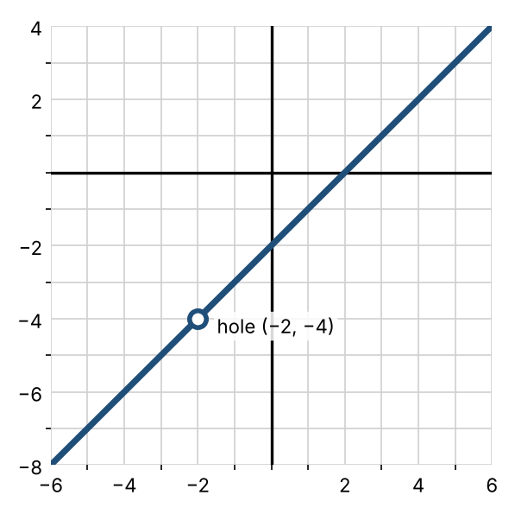

Practice
a. Find the domain of $f(x)=\frac{x+1}{x^{2}−9}$. | b. Find the hole of $f(x)=\frac{x^{2}+5x+6}{x+3}$. | c. Find the hole of $f(x)=\frac{x^{2}−x−6}{x^{2}−4}$.

Skill 9.2: Vertical Asymptotes & Intercepts

Key ideas
- A vertical asymptote is a ______________ (4) line $x=a$ that the graph approaches as the y-values grow without bound.
- Notation: $f(x)→∞$ as $x→a⁺$ means "as x approaches a from the right, f(x) grows without bound." $x→a⁻$ means from the left.
- Vertical asymptotes are the zeros of the denominator of the ______________ (5) form.
- y-intercept: $R(0)$, if 0 is in the domain.
- x-intercepts: the zeros of the ______________ (6) of the reduced form.

Example 1: vertical asymptotes
- $g(x)=\frac{x^{2}−x−6}{x^{2}−4}=\frac{(x−3)(x+2)}{(x−2)(x+2)}$. Reduced: $\frac{x−3}{x−2}$. Vertical asymptote $x=2$; $x=−2$ is a hole, not an asymptote.
- $b(x)=\frac{x−2}{x^{2}−1}=\frac{x−2}{(x−1)(x+1)}$. Vertical asymptotes $x=1$ and $x=−1$.

Example 2: intercepts
- $h(x)=\frac{x+3}{2x−5}$: y-intercept $h(0)=−\frac{3}{5}$; x-intercept −3.
- $b(x)=\frac{x−2}{x^{2}−1}$: y-intercept $b(0)=\frac{−2}{−1}=2$; x-intercept 2.

Practice
a. Find the vertical asymptotes of $f(x)=\frac{x+4}{x^{2}−3x−10}$. | b. Find the intercepts of $f(x)=\frac{x^{2}−9}{x^{2}+1}$. | c. For $f(x)=\frac{x^{2}+x−12}{x^{2}−x−6}$, find the hole, the vertical asymptote, and the intercepts.

Skill 9.3: Horizontal & Slant Asymptotes

Key ideas
A horizontal asymptote is a horizontal line $y=b$ that the graph approaches as $x→∞$ or $x→−∞$. Compare the degree N of the numerator with the degree D of the denominator:
Degrees | Asymptote
$N<D$ (bottom heavy) | Horizontal asymptote ________ (7)
$N=D$ | Horizontal asymptote $y=$ (leading coefficient of top)/(leading coefficient of bottom)
$N=D+1$ | Slant (oblique) asymptote $y=Q(x)$, the quotient from dividing
$N>D+1$ | No horizontal or slant asymptote; the ends follow the polynomial quotient

- A graph may cross its horizontal asymptote near the middle of the graph. To check, set the reduced form equal to the asymptote's y-value and solve.
- For a slant asymptote, divide: $p\frac{x}{q}(x)=Q(x)+r\frac{x}{q}(x)$. As $\left|x\right|$ grows, $r\frac{x}{q}(x)→0$, so the graph approaches $y=Q(x)$.

Example 1: horizontal asymptotes
- $f(x)=\frac{1}{x+2}$ and $g(x)=\frac{x+5}{x^{2}+x−6}$: $N<D$, so $y=0$.
- $f(x)=\frac{x+3}{x+2}$: $N=D$, so $y=\frac{1}{1}=1$.
- $f(x)=\frac{3x^{2}+x−1}{2x^{2}−x+4}$: $N=D$, so $y=\frac{3}{2}$.

Example 2: does the graph cross its horizontal asymptote?
- $g(x)=\frac{x+5}{x^{2}+x−6}=0$ when $x=−5$. It crosses $y=0$ at (−5, 0).
- $f(x)=\frac{3x^{2}+x−1}{2x^{2}−x+4}=\frac{3}{2}$: $6x^{2}+2x−2=6x^{2}−3x+12$, so $5x=14$ and $x=\frac{14}{5}$. It crosses at (14/5, 3/2).

Example 3: slant asymptotes
- $f(x)=\frac{x^{2}+1}{x−4}=x+4+\frac{17}{x−4}$. Slant asymptote $y=x+4$.
- $g(x)=\frac{2x^{2}−x+10}{x+3}=2x−7+\frac{31}{x+3}$. Slant asymptote $y=2x−7$.

Example 4: N > D + 1
- $f(x)=\frac{x^{3}+1}{x−2}=x^{2}+2x+4+\frac{9}{x−2}$. No horizontal or slant asymptote; the ends follow the parabola $y=x^{2}+2x+4$.
- $g(x)=\frac{2x^{4}−3x+1}{x^{2}+3}=2x^{2}−6+\frac{−3x+19}{x^{2}+3}$. The ends follow $y=2x^{2}−6$.

Practice
a. Find the horizontal asymptote of $f(x)=\frac{4x−1}{2x+3}$. | b. Find the horizontal asymptote of $f(x)=\frac{x+7}{x^{3}−1}$.
c. Find the slant asymptote of $f(x)=\frac{x^{2}−3x+5}{x−1}$. | d. Does $f(x)=\frac{2x^{2}+3}{x^{2}−1}$ cross its horizontal asymptote?

Skill 9.4: Graphing Rational Functions

Steps: graph a rational function
- Factor the numerator and denominator. State the domain.
- Find any holes, and write the reduced form.
- Find the intercepts from the reduced form.
- Find the vertical asymptotes, and the horizontal or slant asymptote. Check whether the graph crosses the horizontal asymptote.
- Sign test: mark the x-intercepts and vertical asymptotes on a ______________ (8) line. Test one x-value in each interval to see whether the graph is above or below the x-axis.
- Sketch, drawing the hole as an open circle.

Example 1: $g(x)=\frac{x^{2}+x−6}{x^{2}−4}$
- Factored: $\frac{(x+3)(x−2)}{(x−2)(x+2)}$. Domain: $x≠±2$.
- Hole at $x=2$; reduced form $\frac{x+3}{x+2}$, so the hole is (2, 5/4).
- x-intercept −3; y-intercept 3/2.
- Vertical asymptote $x=−2$; horizontal asymptote $y=1$. Setting $\frac{x+3}{x+2}=1$ gives $3=2$, so it does not cross.
Interval | Test x | Sign of g | Graph
(−∞, −3) | −4 | + | Above
(−3, −2) | −2.5 | − | Below
(−2, ∞) | 0 | + | Above

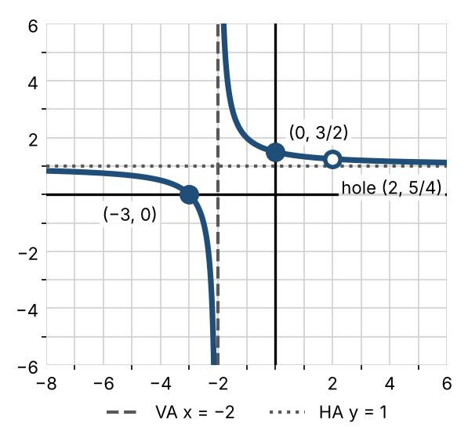

Example 2: $f(x)=\frac{x+1}{x^{2}+4x}$
- Factored: $\frac{x+1}{x(x+4)}$. Domain: $x≠0,−4$. No holes.
- x-intercept −1. No y-intercept, because 0 is not in the domain.
- Vertical asymptotes $x=0$ and $x=−4$; horizontal asymptote $y=0$, crossed at (−1, 0).
- Signs on (−∞, −4), (−4, −1), (−1, 0), (0, ∞): −, +, −, +.
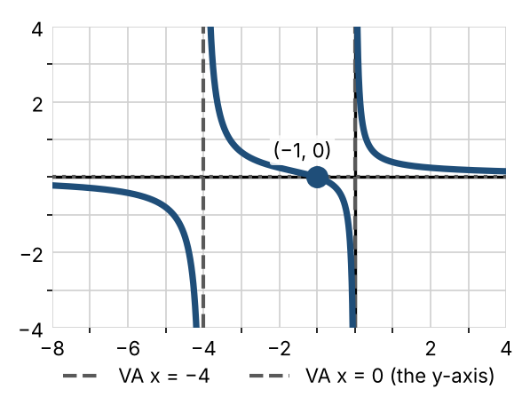

Practice
Find the domain, holes, intercepts, and asymptotes, then sketch.
a. $f(x)=\frac{x^{2}+x−12}{x^{2}−4}$  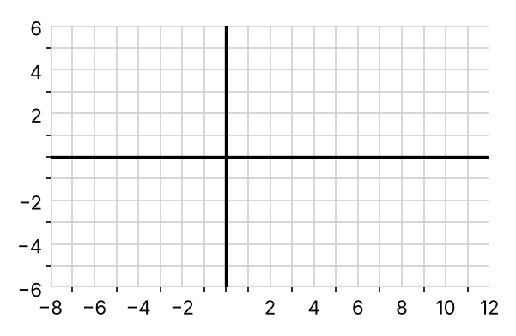 | b. $f(x)=\frac{x^{2}−x−2}{x−3}$  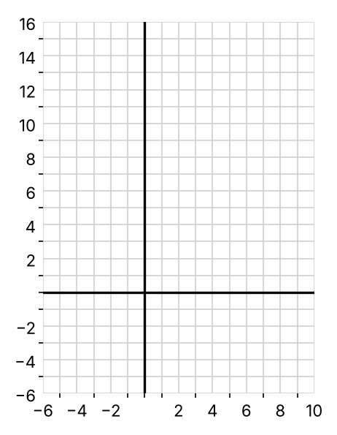 | c. $f(x)=\frac{x^{3}−2x^{2}+3}{x−2}$  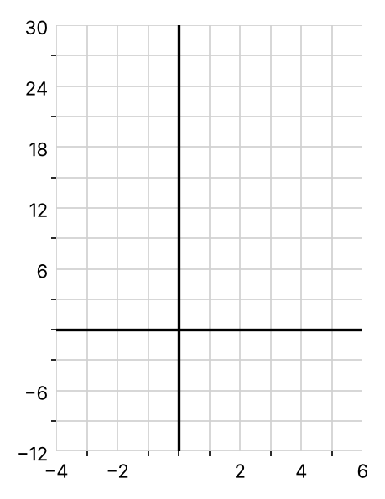

Exit check
1. Find the hole and the vertical asymptote of $f(x)=\frac{x−1}{x^{2}−1}$.

2. Find the horizontal asymptote of $f(x)=\frac{6x^{2}−1}{3x^{2}+x}$.

3. Find the slant asymptote of $f(x)=\frac{x^{2}+2x−1}{x+1}$.

